Manhole Safety Grill Project Doc

Watercare is currently in the process of retrofitting selected manholes with a safety grille, within the Auckland region. The work is to be undertaken by contractors (LendLease and CityCare) who will be using a mobile device (iPad) and mapping application (ArcGIS iOS Collector app) to identify and maintain the manhole’s information. This document outlines all the documentation on setting up this project for iPad using ArcGIS Online.

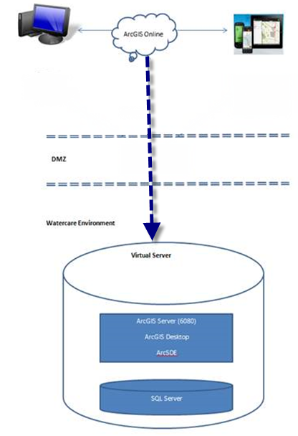

Figure : Project High Level Diagram

The ArcGIS server 10.1 is installed on wsldctgpw2 server with the following configuration.

1. Create a connection to the GISServer - wsldctgpw2

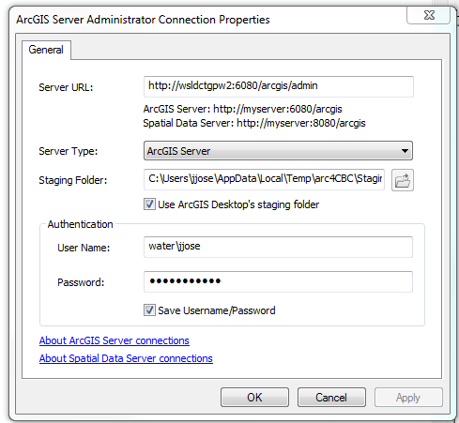

1. The ArcGIS Server Account is water\svc-arcgisgpw2_p

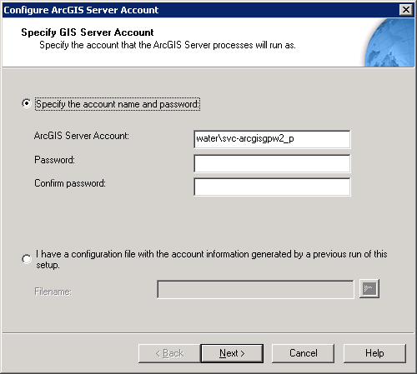

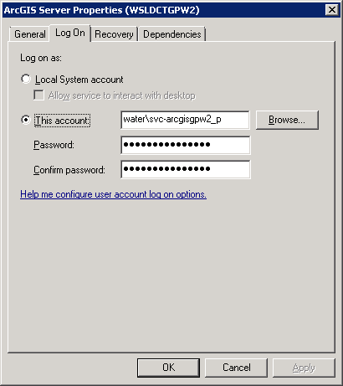

1. Log in on manager [http://wsldctgpw2:6080/arcgis/manager/login.html?url=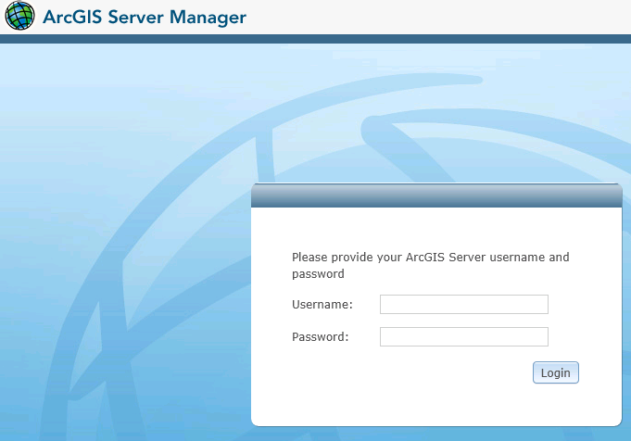](http://wsldctgpw2:6080/arcgis/manager/login.html?url=)

Exclude *water* when logging in.

1. Go to site and register database and folders, otherwise the server will prompt to copy the data to the machine.

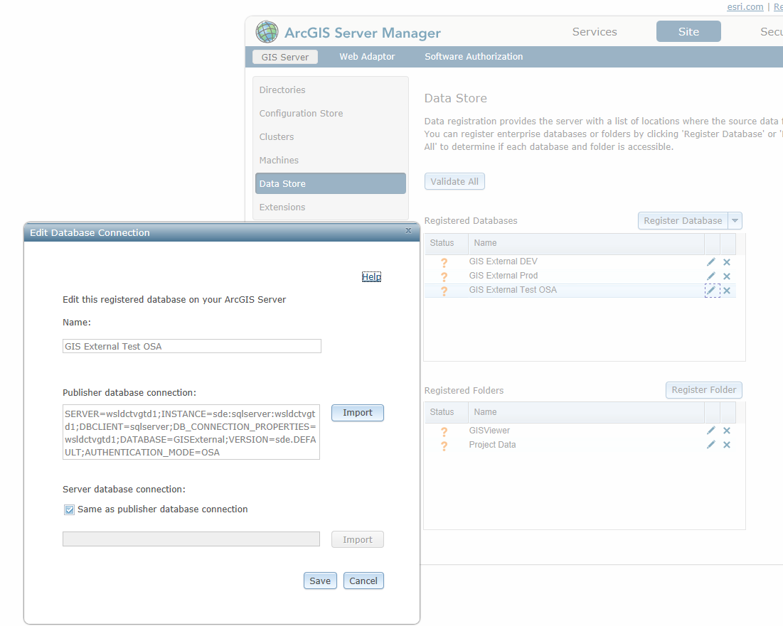

# Step 1 - Data

The data was stored partly in SDE for feature editing purpose and Geodatabase holds the non-editable data. The following steps were taken to set up the data.

1. A new database (External) is created in the WSLDCTVGPD1 with ArcSDE 10.1.
2. A new editable feature class is created in SDE from the existing manholes feature class (Local and Transmission). The feature class and domain schema is located at G:\System\Documentation\ManholeSafetyGrill folder. The backup is stored at G:\Projects\2013\PR13003_ManholeSafetyGrilleProject\Backup\Backup From External Server (MHGrill)\External SDE Data

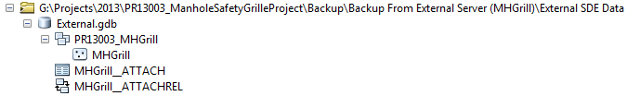

Note: This feature class should be accessible to **GISEditor** group and the Server svc-**arcgisgpw2_p** user.

1. The feature class was enabled with feature attachment functionality to hold photographs.
2. The view only data is stored in the Geodatabase in the \\wsldctgpw2\Projects\Services folder as shown below

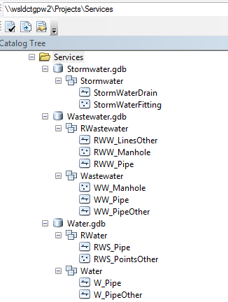

1. The basemap data is accessed from Auckland Council Aerials basemap service.

# Step 2 – Services

The above data is hosted as map and feature services as explained below.

1. MHGrill Feature Service – A feature data access service is created by publishing a MXD containing the manholes feature class. The MXD contains the three layers all looking at the same feature class. The MXD is stored at \\wsldctgpw2\Projects\PR13003_MHGrill\MXD\ManholeGrill.mxd

*Note : These point features would require attribute identification and listing. Apple devices (at the time of compiling this document) don’t detect very small points. For display on Apple devices the symbology should be set big enough such that touch features can be detected by the device*.

Three layers were created with unique symbology to cater for the three workflows using definition queries as below.

|  |  |  |
| --- | --- | --- |
| Layers | Symbology Field | Definition Query |
| Inspection QA | QA Check | GRILL_INSTALLED NOT LIKE 'Not Processed' |
| Grill Installation | Grill Installed | QA LIKE 'Not Checked' |
| Manhole Assessment | Manhole Location | GRILL_INSTALLED LIKE 'Not Processed' |

The service URL is <http://remote.water.co.nz:8484/ArcGIS/rest/services/MHGrill/ManholeGrill/FeatureServer>.

(jjose) <http://wsldctgpw2:6080/ArcGIS/rest/services/MHGrill/ManholeGrill/FeatureServer>

The service is then secured and access provided to **GISAdmin** and **SEC_GISEWebEditorMHS** AD groups. Please see below screenshot.

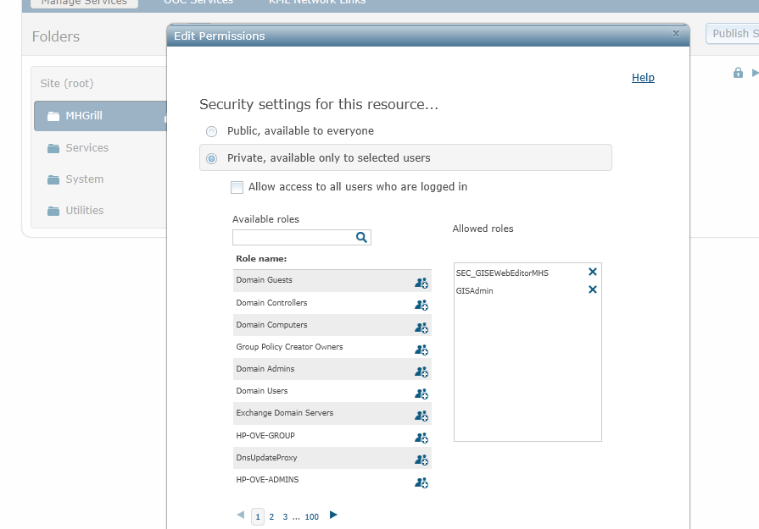

1. Service Network Map Service – This map service is used for displaying the service network data and is created by publishing this MXD \\wsldctgpw2\Projects\PR13003_MHGrill\MXD\ServiceNetwork.mxd

The map service contains water and waste water pipes data. For storm water only manholes were displayed as to make a distinction from the waste water manholes. The symbology is kept as the standard Watercare symbology.

The service url is <http://remote.water.co.nz:8484/ArcGIS/rest/services/Services/ServiceNetwork/MapServer>

(jjose) <http://wsldctgpw2:6080/ArcGIS/rest/services/Services/ServiceNetwork/MapServer>

The map service is then secured and all Watercare users were given access by checking the ‘Allow access to all users who are logged in’. See screenshot below.

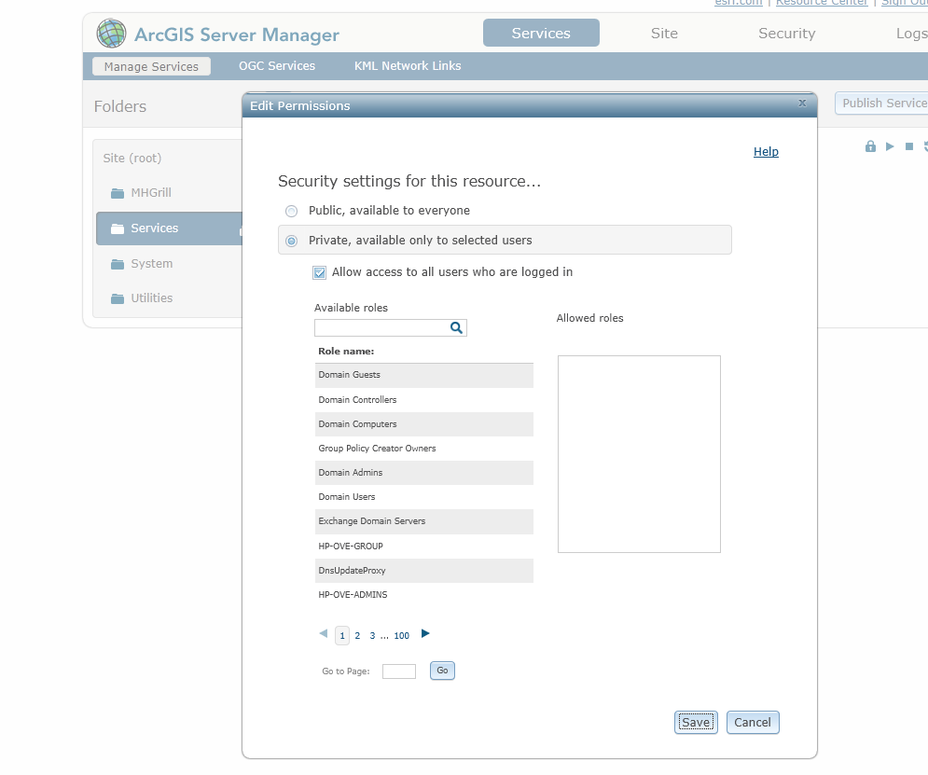

Note – The <http://remote.water.co.nz:8484/ArcGIS/rest/services/Services/ServiceNetwork/MapServer> rest services link doesn’t work from the pc on the Watercare internal domain. So to access these services a new laptop was used with 3G data card.

# Step 3 – Webmap

The entire project workflows are based on three webmaps created on Auckland Council ArcGIS online account. The webmaps are created using the following steps.

1. The webmaps were created over **Subodh@Watercare** Auckland Council AGOL account.
2. There webmaps were then shared to **Manhole Grill** group.
3. A user account is created in Auckland Council AGOL account as **watercaregis**.
4. The **watercaregis** account is then added to this **Manhole Grill** group so that the end users can access the webmaps on iOS devices using this shared account.
5. A single webmap was created to capture one workflow. The webmap consist of following layers.
   1. The Auckland Council aerials basemap layer
   2. A display only service network layer is created to display the Watercare pipe network and AC storm water manholes As this service is secured, to avoid users to enter credentials , the user (*GISEWeb*) and password has been embedded . This is achieved by using the Add Item functionality in AGOL as shown below.

URL: <http://remote.water.co.nz:8484/ArcGIS/rest/services/Services/ServiceNetwork/MapServer>

(jjose) <http://wsldctgpw2:6080/ArcGIS/rest/services/Services/ServiceNetwork/MapServer>

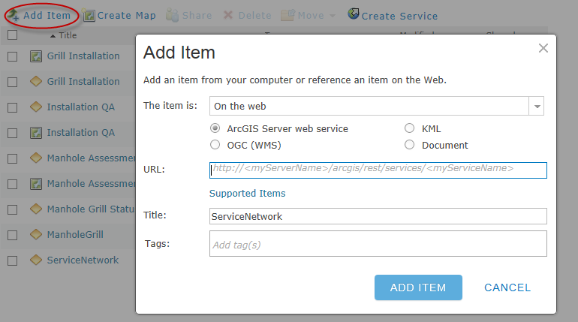

* 1. A feature service to capture the work and the photos is used with unique display symbology and definition query. The feature service is also added using Add Item functionality first to the AGOL account. This is done because of the issue same issue of the services not accessible on pcs in Watercare domain (It makes it easier to add feature service using internal pcs).

The following table explains the services used on the three webmaps created for this project.

Webmap

|  |  |  |  |
| --- | --- | --- | --- |
| WebMap | Inspection QA | Grill Installation | Manhole Assessment |
| Basemap | Aerial | Aerial | Aerial |
| Map Service | Service Network | Service Network | Service Network |
| Feature Service | MHGrill (layer Id 0) | MHGrill (layer Id 1) | MHGrill (layer Id 2) |

Services

Please refer to the below screen shots for more details on the webmaps.

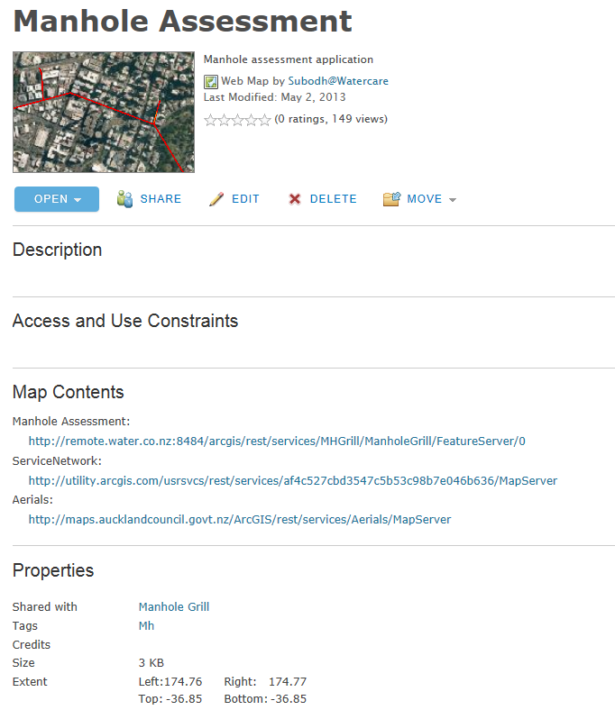 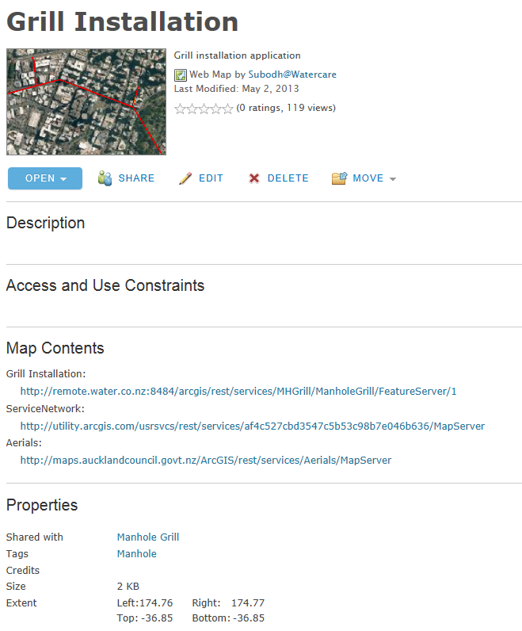

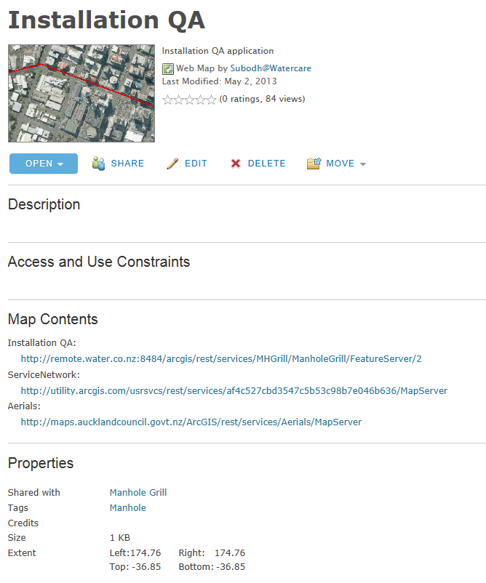

# Step 4 – Setting up iOS Applications

The above webmaps can be used on mobile and pcs. The webmaps automatically configures to the hardware and can works on Android and iOS devices. For this project these applications were used on the iPads but can also work on iPhones with no additional configuration. The steps below describe how to set up the application on an iPad.

1. Download Esri iPad app or Esri Collector app from AppStore.
2. Log into the app using **watercaregis** account.

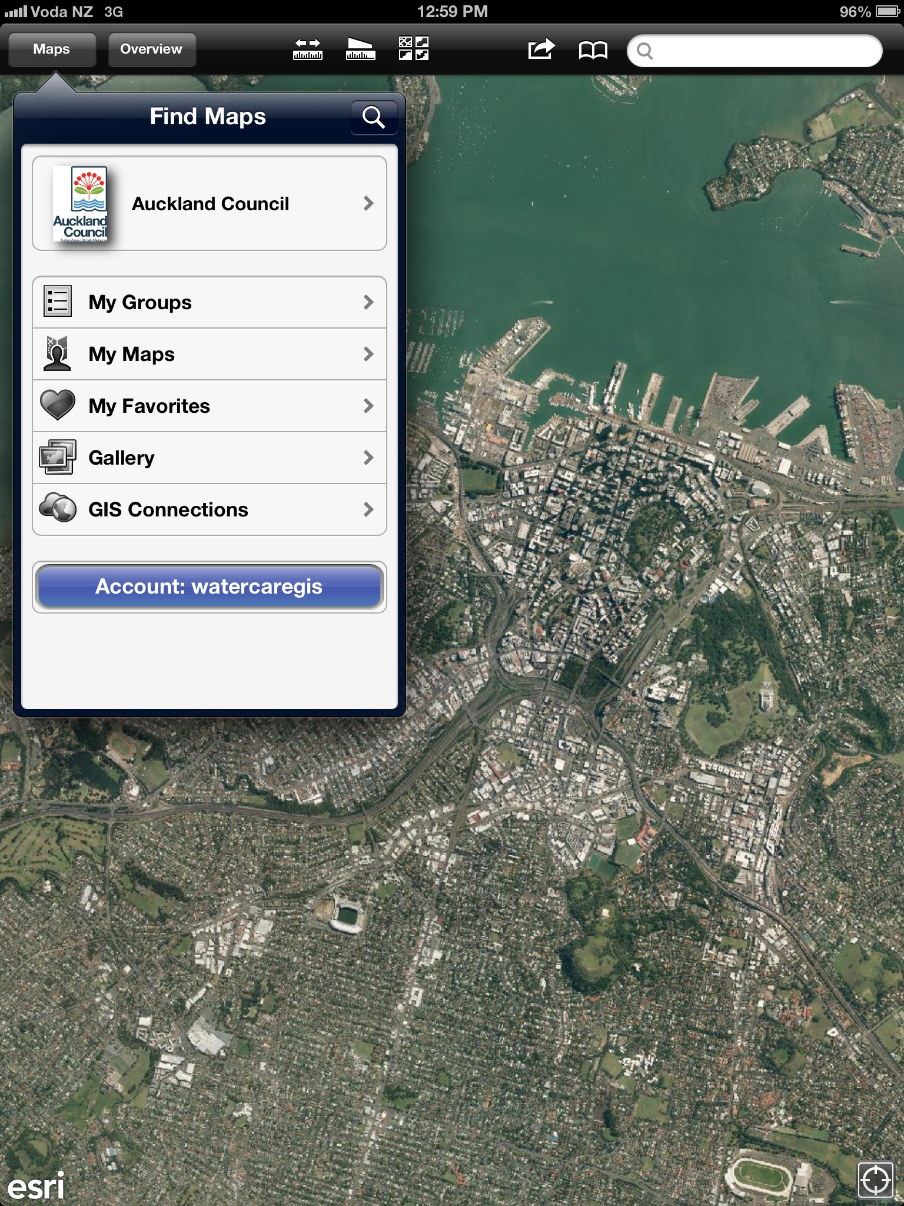

1. Go to **My Groups** and then **Manhole Grill** group.

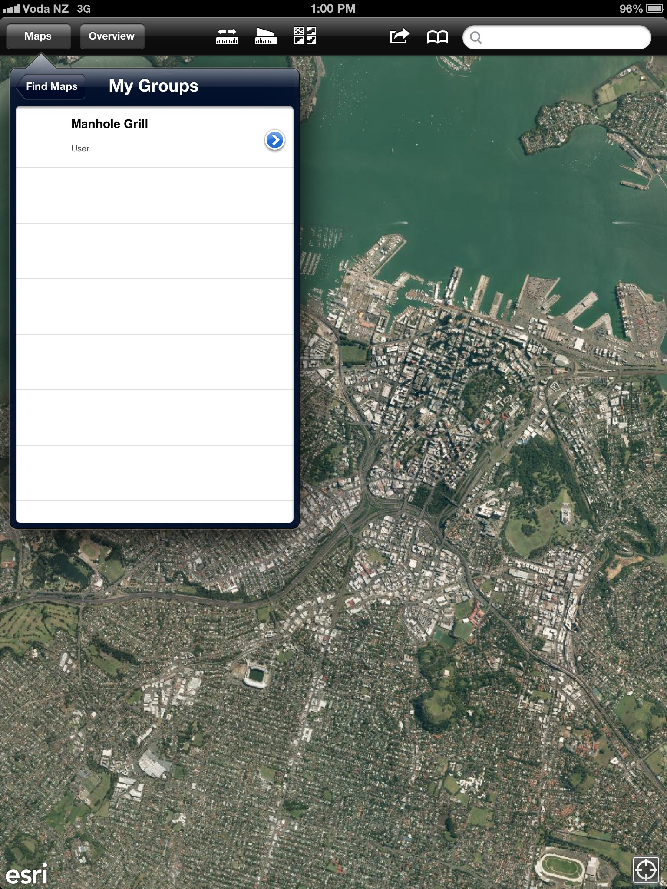

1. You should see three workflow apps as **Installation QA**, **Grill Installation** and **Manhole Assessment.**

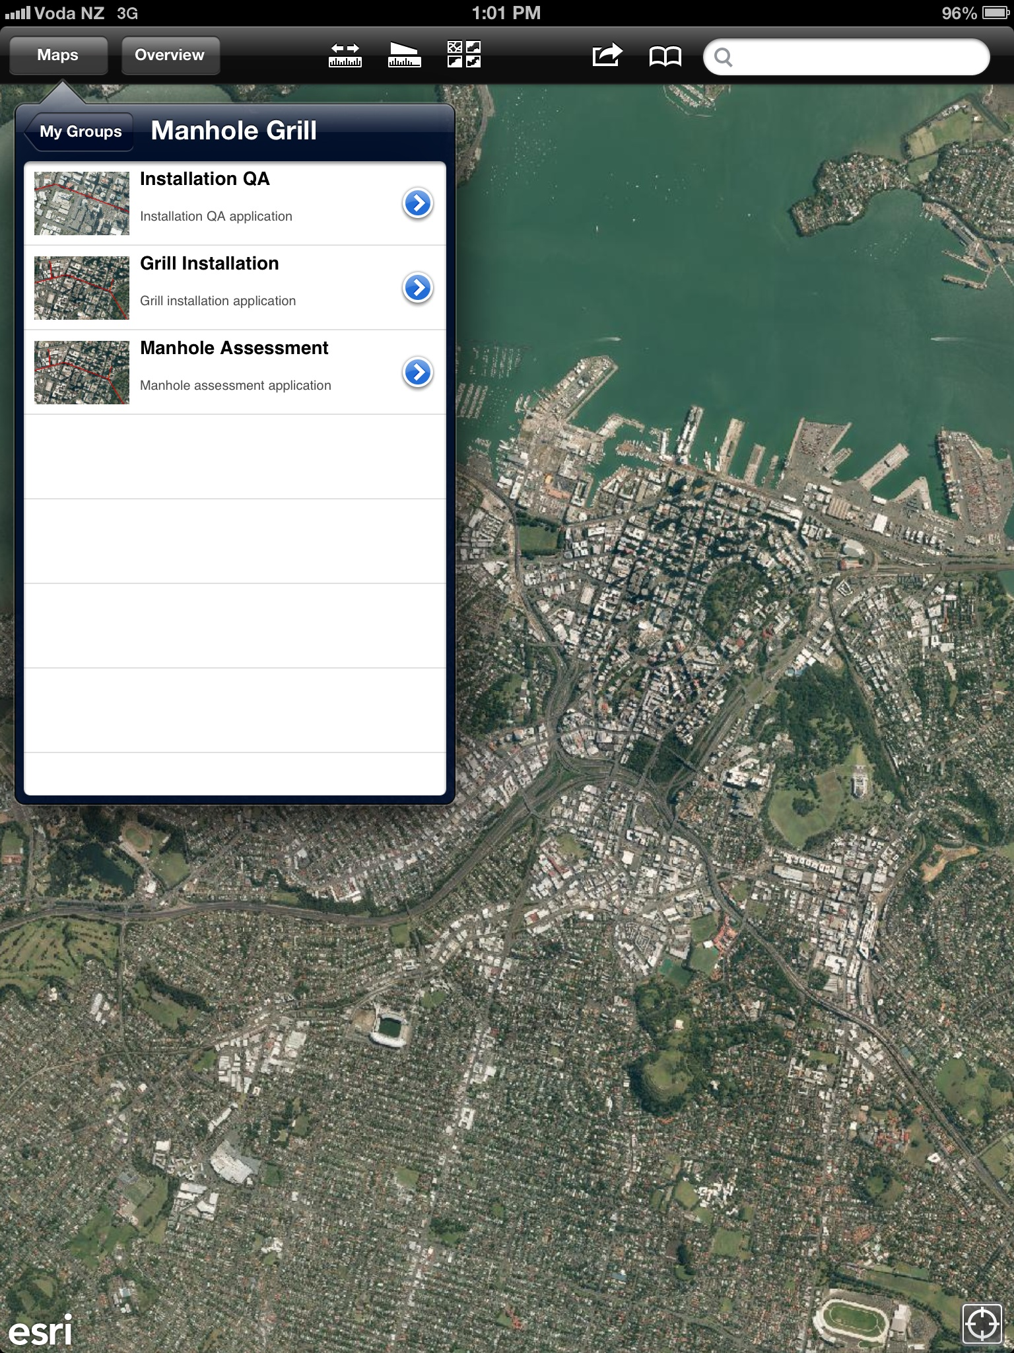

1. Tap on the workflow app, you want to capture data for, enter credentials when asked. Now you are ready to capture data.

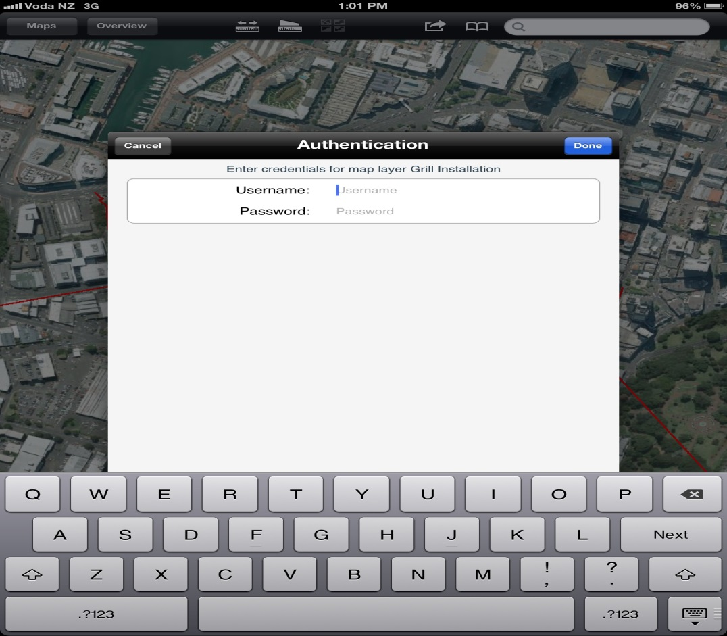

Note: The application consumes the secured Manhole Grill service from Watercare external GIS server. Only the AD user’s part of **SEC_GISEWebEditorMHS** group can access this service. If you are a member of this group, enter your Watercare credentials to capture data.